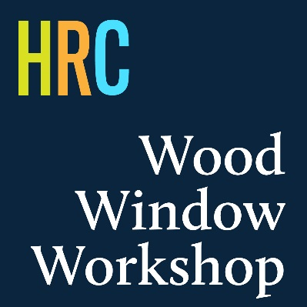

Call for Applicants and Nominations - Wood Window Workshop 2020
The AIA Houston Historic Resources Committee will be hosting our 3rd annual Wood Window Workshop in March of 2020, and we're looking for double-hung wood windows to restore! We are accepting applications and nominations of buildings to host the workshop, which will take place on a weekend in March 2020. The exact date will be coordinated following the building selection process. The past two AIA Houston Wood Window Workshops took place at 1548 Heights church, a City of Houston Protected Landmark, during a two-day weekend event. Each event hosted over 30 registered attendees, ranging from AIA members, architects, engineers and community members and several double-hung wood windows of the building were restored.
Please read the eligibility requirements. The building that hosts the workshop will have many of its windows restored by workshop participants, free of charge to the building owner. The recommended contribution by the building owner is breakfast and/or lunch on Saturday and Sunday of the workshop for approximately 45 volunteers and participants. The workshop will be led by Steve Quillian, respected preservationist and craftsman, who hosted the past two AIA Houston Wood Window Workshops. For more on Steve's work see: https://www.woodwindowmakeover.com/

Deadline: All nominations must be submitted by 5pm on November 8, 2019

Eligibility:
- Buildings nominated must have double-hung wood windows
- Buildings may be nominated by anyone but will require owner consent and involvement. The building owner or designated owner’s representative should be willing to participate during the planning of the workshop
- Priority will be given to nonprofit organizations
- Buildings nominated must be in Harris County
- Buildings nominated must have a minimum of 8 double-hung wood windows in need of repair
- Buildings nominated must have a current certificate of occupancy
- Buildings nominated are not required to be historically designated
- For any questions about eligibility, please contact Rhonda Lowe at rhonda@aiahouston.org

Application Criteria
The application package for the nomination should include:
- Questionnaire (see below)
- Photos (3)
  - Overall Building, Typical Window 1, Typical Window 2. Ensure that the condition of windows is reflected on the window photos.

Questionnaire:
1. Applicant is: Building Owner [_] Nominator [_]
2. Building Address
3. Building Neighborhood
4. Building Architectural Description (500 words max)
5. Current Building Use (100 words max)
6. Impacted by Hurricane Harvey? Yes [_] No [_]
7. Historic Designation (List designation, type if applicable)
8. Building Construction Date (If available)
9. List how many double-hung wood windows the building has
10. Applicant/Nominator name and contact information (phone and email)
11. Owner's name and contact information (phone and email)
12. Is there anything additional you’d like to share about your nomination? (500 words max)

Email application to rhonda@aiahouston.org

